
CSE 1116, Object Oriented Programming Lab Section I, Summer 2024, MoI
Total Marks: 15, Time :45 minutes
Mid Examination
Name:
Student ID: | Obtained Marks:
Any examinee found adopting unfair means will be expelled from the trimester / program as per UIU disciplinary rules.

Question 1: (Inheritance, Polymorphism, Encapsulation) [15]

Consider the following UML diagram. -, + and # means private, public and protected access respectively. Design all classes so that running the main method code matches given output.

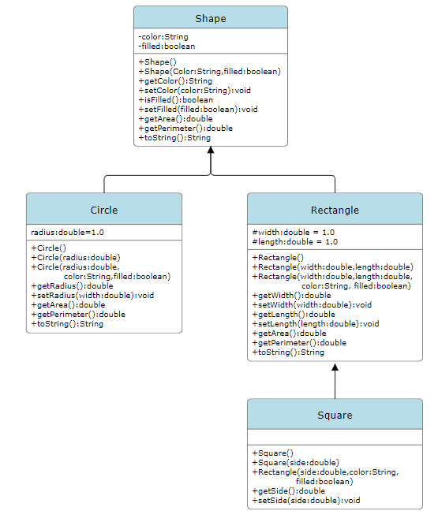
+toString()

Consider the following code for the Main class.
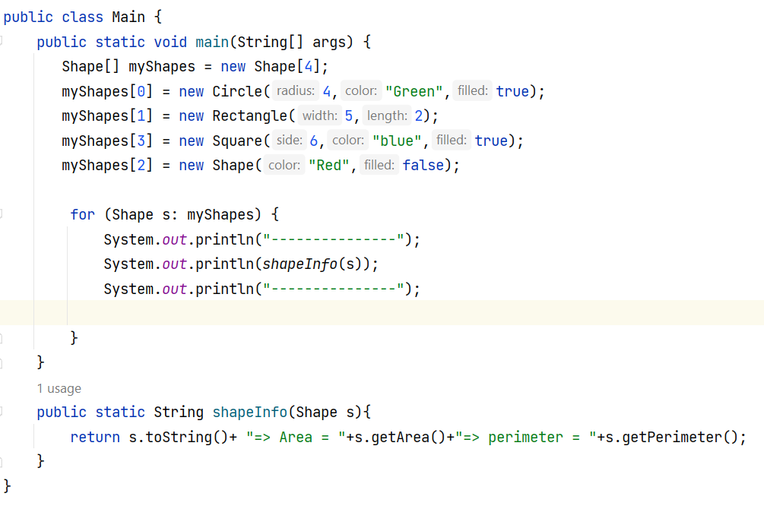
Also consider the following output generated after executing the main method.

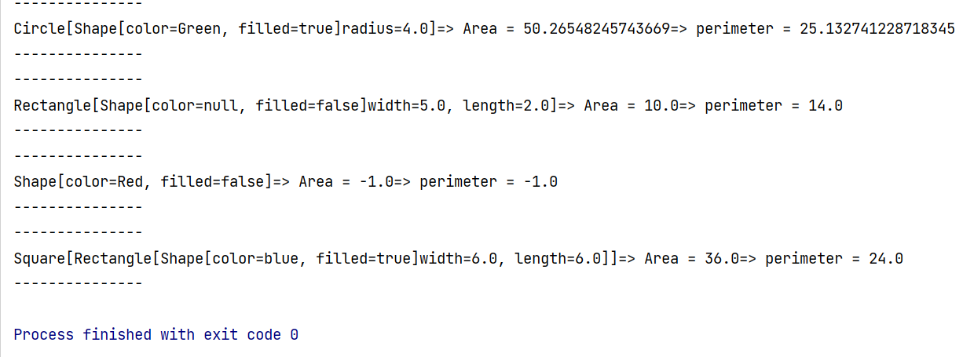

Marks Table (for faculty use):
Shape(3) | Rectangle(4) | Circle(4) | Square (4)

